**Assignment 2:**

**Aim:** Finalizing a Problem Statement.

**Objective:** Apply Design Thinking Tools; (1) Interview Techniques and (2) Empathy Map and submit a Problem Statement.

**Theory:**

1. **Initial Problem Statement:**  Addressing Challenges of Excessive Screen Time in Young Children.

**Idea:**

The initial problem statement addresses the pervasive issue faced by parents in managing their children's screen time effectively. With the widespread use of digital devices and entertainment platforms, children are increasingly exposed to screens for extended periods, which can have adverse effects on their mental, physical, and emotional well-being. The proposed idea revolves around developing a comprehensive solution that goes beyond mere surveillance to actively promote positive digital habits and enhance children's overall development.

**Input/Output:**

The input for the solution includes information about the child's daily routines, family dynamics, thoughts on technology's role in development, non-screen entertainment activities, emotional observations during favorite activities, struggles in regulating screen time, ideal screen time durations, strategies for managing screen time, emotional responses to screen time limitations, assumptions about screen time content, and approaches to turning non-screen activities into enjoyable adventures.

The output is envisioned as a comprehensive application or strategy that provides insights into screen time usage, offers educational and recreational content tailored to children's interests and age, promotes positive communication within families, and encourages a balanced approach to screen time management.

**Motivation behind Idea:**

The motivation behind the idea stems from the recognition of the detrimental effects of excessive screen time on children's well-being and the strained relationships it can create within families. Existing solutions often focus solely on surveillance and content restriction, lacking integration with children's learning and development needs. The aim is to create a solution that respects children's autonomy while supporting parents in fostering healthy digital habits and meaningful interactions with technology. The goal is to bridge the gap between monitoring screen time and promoting holistic child development in a way that enhances the overall family dynamic.

1. **Brief Theory of Interview Techniques:**

Interview techniques are systematic approaches used to gather information, insights, and perspectives from individuals or groups. They are employed across various domains, including research, market analysis, user experience design, and problem-solving. Here are some key aspects of interview techniques:

a. Purpose: Interviews serve specific purposes such as understanding user needs, exploring market trends, uncovering pain points, or gathering feedback on products or services.

b. Types of Interviews: Interviews can be structured, semi-structured, or unstructured, depending on the level of flexibility in the questioning process and the degree of predefined topics.

c. Questioning Techniques: Interviewers use various questioning techniques to elicit relevant information and encourage participants to share their thoughts and experiences. These may include open-ended questions, closed-ended questions, probing questions, and follow-up questions.

d. Active Listening: Effective interviewers practice active listening, paying close attention to verbal and non-verbal cues, and demonstrating empathy and understanding towards the interviewees.

e. Rapport Building: Building rapport with interviewees is crucial for creating a comfortable and open environment where participants feel encouraged to share their insights candidly.

f. Documentation and Analysis: Interview data is typically documented through notes, recordings, or transcripts and analyzed to identify patterns, themes, and key takeaways that inform decision-making and problem-solving processes.

Overall, interview techniques play a vital role in gaining valuable insights, validating assumptions, and informing the design and development of products, services, and solutions.

1. **Brief Theory of Empathy Map:**

Empathy maps are visual tools used to gain deeper insights into the thoughts, feelings, needs, and behaviors of users or stakeholders. They help designers, researchers, and teams develop a more empathetic understanding of their target audience and create solutions that address their needs effectively. Here are the key components of empathy maps:

a. Persona: Empathy maps are often centered around a specific persona representing the target user or stakeholder. This persona encapsulates demographic information, goals, motivations, challenges, and preferences.

b. Four Quadrants: Empathy maps typically consist of four quadrants representing different aspects of the user's experience:

Says: What the user says verbally, including quotes, opinions, and expressions.

Thinks: The user's thoughts, beliefs, attitudes, and internal dialogues.

Does: Observable actions, behaviors, gestures, and interactions.

Feels: The user's emotions, desires, fears, and aspirations.

c. Insights and Observations: Empathy maps are populated with insights and observations gathered through research, interviews, observations, and user testing. These insights provide valuable context and help team members develop a deeper understanding of the user's perspective.

d. Collaborative Tool: Empathy maps are often used collaboratively, with cross-functional teams coming together to share their observations, interpretations, and insights. This collaborative approach fosters empathy and ensures that diverse perspectives are considered in the design process.

e. Iterative Process: Empathy maps are dynamic tools that evolve over time as new insights emerge and the understanding of the user's needs deepens. Designers continuously refine and update empathy maps throughout the design and development lifecycle.

By leveraging empathy maps, teams can align their efforts, prioritize features, and design solutions that resonate with users on a more emotional and human level, ultimately leading to more meaningful and impactful outcomes.

1. **Interview Questions:**

1. What's a regular day like for you and your family? Any exciting routines?

2. What thoughts come to your mind regarding the role of technology in your child's overall development?

3. How do you keep the family entertained away from screens? Spill the secrets to your non-digital family fun!

4. What emotions do you observe in your child when they are involved in their favorite activities?

5. What are the epic battles you face in reigning in your kid's screen time? Any legendary struggles?

6. If you had a magic remote control for screen time, what would be the enchanted duration you think is perfect for your child's well-being?

7. Share the secret weapons or tech tools you use to keep a leash on your child's screen time. Any cool gadgets?

8. When you put the brakes on screen time, what kind of emotional rollercoaster does your child hop on? Are we taking a joyride or a mini meltdown?

9. Let's chat about the parent scene! Have you had any interesting talks with other parents regarding your child's digital adventures? Feel free to share.

10. Time for some guessing games! What assumptions do you cook up about the content your kiddo dives into during screen time?

11. What's your special formula for turning non-screen activities into a joyous adventure for your kid?

12. In your opinion, how does your child's screen time impact their interactions with peers or siblings, and what emotions come into play?

13. When your little one demands more screen time, what's your usual response? Any epic comebacks?

14. How do you handle situations when your child exceeds the agreed-upon screen time limits?

15. If you could envision a futuristic solution that perfectly balances screen time, learning, and family vibes, what would it look like? Describe your dream tech that makes parenting a breeze while nurturing your child's growth.

1. **Interview Answers and Empathy Map (Individual):**

1. What's a regular day like for you and your family? Any exciting routines?

→

Response 1: Our typical day involves a mix of work, school, and family time. We have established routines for meals, homework, and bedtime stories. It's quite structured, but we try to incorporate some outdoor activities and games to keep things exciting.

Response 2: In our family, each day varies. Balancing work commitments and the kids' schedules can be challenging. We have a few regular activities like family dinners and movie nights. We're always looking for new ways to make our time together more engaging and enjoyable.

Response 3: Our family's routine is dynamic, considering work and school commitments. We do have a dedicated time for meals and family discussions. We try to make weekends more exciting with outdoor adventures or creative projects.

Response 4: Our days are quite busy with work, school, and extracurricular activities. We have set routines for homework and chores, but we also value spontaneous family moments.

2. What thoughts come to your mind regarding the role of technology in your child's overall development?

→

Response 1: I believe technology plays a significant role in my child's development, offering both opportunities and challenges. While it can enhance learning, the excessive screen time raises concerns about their well-being.

Response 2: Technology is a double-edged sword in my child's development. On one hand, it opens doors to knowledge, but on the other, prolonged screen exposure worries me.

Response 3: I see technology as a powerful tool for my child's growth, but I'm mindful of the potential downsides.

Response 4: Technology is an integral part of my child's life, aiding in education and entertainment. However, I'm concerned about how it might impact their holistic development.

3. How do you keep the family entertained away from screens? Spill the secrets to your non-digital family fun!

→

Response 1: We often engage in outdoor activities like hiking or biking as a family. Board games and puzzle nights are also a hit in our household, providing a great way to bond without screens.

Response 2: We've embraced a weekly family movie night, complete with homemade popcorn and cozy blankets. Cooking together is another favorite; it not only keeps us away from screens but also allows us to share some quality time.

Response 3: Our family loves exploring local parks and nature reserves. We've also introduced themed nights where each family member takes turns picking an activity – from arts and crafts to karaoke. It keeps things exciting and screen-free.

Response 4: Game nights are a staple for us. Whether it's card games, charades, or strategy board games, we enjoy the friendly competition and laughter. We've found it's a fantastic way to unwind and connect without the distraction of screens.

4. What emotions do you observe in your child when they are involved in their favorite activities?

→

Response 1: I notice my child expressing joy and enthusiasm when engaged in their favorite activities. It's heartening to see them genuinely excited and happy.

Response 2: Observing my child during their favorite activities, I often see a sense of concentration and curiosity. They seem deeply absorbed and interested in what they're doing.

Response 3: When my child is immersed in their preferred activities, I can see a mix of creativity and determination. It's inspiring to witness their imagination at work.

Response 4: I've noticed a range of emotions in my child during their favorite activities, from pure delight to a sense of accomplishment. It's a reassuring sign that they're enjoying and benefiting from their interests.

5. What are the epic battles you face in reigning in your kid's screen time? Any legendary struggles?

→

Response 1: Screen time battles often revolve around constant negotiations and disagreements, making it challenging to strike a balance between allowing entertainment and ensuring productive use. The struggle is real.

Response 2: It's an ongoing challenge to limit screen time without creating friction at home. Finding the right boundaries is tough, especially when my child insists on more screen time for entertainment.

Response 3: The constant tug-of-war between wanting to ensure my child's screen time is monitored and facing resistance from them is a daily struggle. It's tough to maintain harmony while addressing this issue.

Response 4: Balancing my desire to regulate screen time for my child's well-being and their resistance to restrictions creates a significant ongoing battle. It's crucial to find a solution that aligns with both our needs.

6. If you had a magic remote control for screen time, what would be the enchanted duration you think is perfect for your child's well-being?

→

Response 1: Ideally, we believe that a daily screen time limit of 1.5 hours would strike a balance between allowing our child to explore digital content and ensuring they engage in other activities for holistic development.

Response 2: We envision a magic screen time duration of 2 hours a day. This allows for a healthy mix of educational and recreational content, fostering a well-rounded experience for our child without overindulging in screen activities.

Response 3: For our child's well-being, we think a magical screen time limit of 1 hour daily would be optimal. This duration aims to provide a controlled exposure to screens while encouraging more time for physical activities and face-to-face interactions.

Response 4: In our perspective, the enchanted screen time duration should be around 1.5 hours. This allows for a balanced approach, incorporating educational content and leisure activities, while ensuring our child has ample time for offline pursuits for their overall growth.

7. Share the secret weapons or tech tools you use to keep a leash on your child's screen time. Any cool gadgets?

→

Response 1: We prioritize open communication with our child about screen time limits. No fancy gadgets, just setting expectations and discussing the importance of a balanced routine.

Response 2: We use a reward system tied to reduced screen time. Simple incentives like extra playtime or a small treat encourage our child to self-regulate without the need for specific tech tools.

Response 3: Our strategy involves integrating educational apps into our child's screen time. We choose apps that combine learning and fun, ensuring a positive and enriching experience without resorting to external gadgets.

Response 4: We've found success in using parental control features on devices, setting daily limits and restricting certain content. While not revolutionary, it provides a straightforward way to manage screen time within defined boundaries.

8. When you put the brakes on screen time, what kind of emotional rollercoaster does your child hop on? Are we taking a joyride or a mini meltdown?

→

Response 1: Some days it feels like a joyride, especially when we replace screen time with engaging activities. However, there are instances of mini meltdowns, especially when abrupt restrictions are imposed.

Response 2: It's a mix, honestly. Initially, there's a resistance and a bit of frustration leading to a mini-meltdown.

Response 3: There's definitely a meltdown phase when we limit screen time.

Response 4: It's a bit of both – a mix of joyride and a mini-meltdown. Initially, there's resistance, but once they find alternative fun activities, it turns into a more positive experience.

9. Let's chat about the parent scene! Have you had any interesting talks with other parents regarding your child's digital adventures? Feel free to share.

→

Response 1: Yes, many parents express concerns about their kids' screen time. It's challenging to strike a balance between allowing them to explore the digital world and ensuring it doesn't negatively impact their development.

Response 2: Absolutely, the topic comes up often. We've discussed how existing solutions are somewhat restrictive and don't cater to the diverse needs of children. Finding a way to make screen time more meaningful is a common theme.

Response 3: Indeed, I've had conversations with fellow parents. The consensus is that while monitoring is necessary, there's a desire for a solution that not only limits screen time but also engages kids in a positive and educational manner.

Response 4: Yes, some parents are genuinely shocked when they realize the negative impact of excessive screen time on their children. Creating awareness about these effects becomes crucial for informed parenting decisions.

10. Time for some guessing games! What assumptions do you cook up about the content your kiddo dives into during screen time?

→

Response 1: As a parent, my assumption is that the current content my child engages with during screen time lacks effective curation, potentially exposing them to content that may not be suitable for their age or development.

Response 2: I assume that my child's screen time activities might not contribute significantly to their learning and overall development. There is a concern that the content may be more entertainment-focused rather than educational.

Response 3: We assume our child engages in a mix of educational and recreational content, but it's challenging to know for sure.

Response 4: Our assumption is that our kid consumes a variety of content, but pinpointing the educational value is tricky.

11. What's your special formula for turning non-screen activities into a joyous adventure for your kid?

→

Response 1: For us, it's all about making offline activities exciting. We focus on hands-on experiences, creating a balance between learning and play.

Response 2: Our special formula involves introducing challenges and rewards, turning every non-screen moment into a happy adventure for our kid.

Response 3: In our family, we've discovered the magic of blending non-screen activities with storytelling. Whether it's a simple task or a more complex project, narrating engaging stories around the activity makes it an enjoyable adventure.

Response 4: Our approach centers on creativity and exploration. We've found that adding an element of surprise and discovery to non-screen activities sparks our child's curiosity.

12. In your opinion, how does your child's screen time impact their interactions with peers or siblings, and what emotions come into play?

→

Response 1: My child's screen time has affected their interactions negatively. Sibling relationships are strained, and social skills with peers have diminished. Emotions range from irritability to a sense of detachment.

Response 2: They seem more engrossed in virtual activities, leading to decreased face-to-face engagement. Emotions involved include frustration and occasional isolation.

Response 3: There's a noticeable decrease in shared activities, leading to feelings of detachment and occasional conflicts.

Response 4: I've noticed that excessive screen time has somewhat isolated my child from interactions with peers and siblings. Emotionally, there's a mix of irritability and reluctance to engage in other activities, contributing to strained relationships at times.

13. When your little one demands more screen time, what's your usual response? Any epic comebacks?

→

Response 1: I usually try to negotiate with my child by suggesting alternative activities or setting specific time limits. Epic comebacks? Not really, just a lot of explaining why balance is important.

Response 2: I often find myself redirecting my child's attention to outdoor activities or educational games. No epic comebacks, just a constant reminder of the importance of a well-rounded childhood.

Response 3: I've set clear rules about screen time, and when my child demands more, I simply stick to those guidelines. Epic comebacks? Well, maybe just a firm 'no' and a reminder of the agreed-upon limits.

Response 4: I've integrated screen time into a reward system for completing chores or homework. So, when my little one demands more, I use it as an opportunity to reinforce the importance of responsibilities. No epic comebacks, just a bit of positive reinforcement.

14. How do you handle situations when your child exceeds the agreed-upon screen time limits?

→

Response 1: Honestly, it's a constant struggle. We've tried using parental control apps, but it often leads to disagreements with our child. We end up negotiating and compromising, but it's not an ideal situation. Any solution that helps manage this without creating tension would be greatly appreciated.

Response 2: We're quite strict about screen time, and if our child goes over the limits, we simply restrict access for a certain period. However, this sometimes results in a strained relationship.

Response 3: We've established some screen time rules, but it's tough to enforce them consistently. We've tried a few apps, but they focus more on restrictions than on fostering a healthy relationship with technology.

Response 4: Typically, we set clear boundaries with our child about screen time. If they exceed the agreed limits, we enforce consequences such as reducing their screen time the next day. It's a bit challenging, and we're open to a solution that could make this process smoother.

15. If you could envision a futuristic solution that perfectly balances screen time, learning, and family vibes, what would it look like? Describe your dream tech that makes parenting a breeze while nurturing your child's growth.

→

Response 1: A seamless blend of interactive educational content and entertainment in a single app, ensuring our child is engaged in meaningful activities. Real-time insights into screen time with gentle nudges for breaks, fostering a healthy balance between learning and leisure.

Response 2: I imagine a smart system that understands my child's interests and tailors educational content accordingly. It should provide detailed reports on screen time, suggesting personalized learning experiences. Importantly, it should promote positive communication within the family about technology use.

Response 3: My dream solution would integrate an engaging virtual world where learning is intertwined with fun activities. It should adapt to my child's age, ensuring age-appropriate content, and allow me to customize screen time limits. A user-friendly interface and insights on my child's progress would be key features.

Response 4: A holistic approach that not only tracks screen time but also facilitates a diverse range of activities, promoting physical, mental, and social development. The ideal solution should act as a supportive tool for parents, encouraging a positive environment at home while nurturing the child's overall growth.

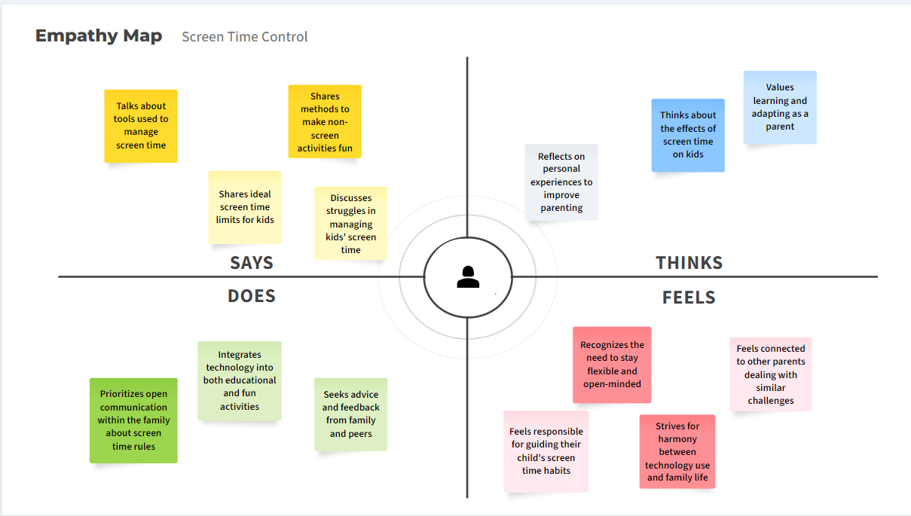

1. **Team’s Combined Empathy Map:**

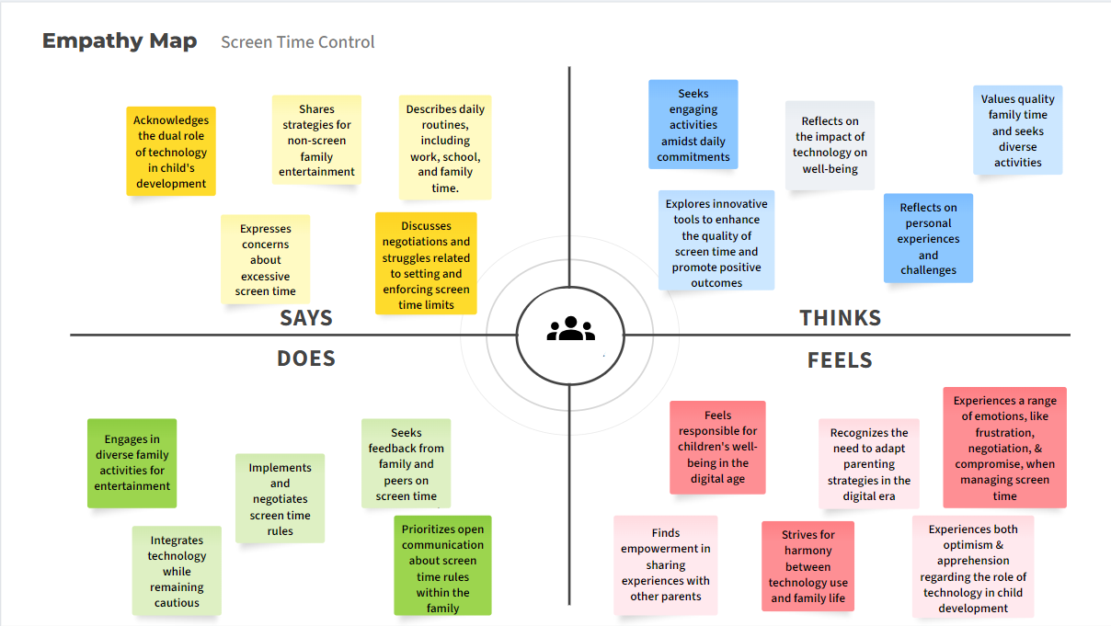

1. **Analysis of Empathy Map, Observations and Reasons for Accepting / Rejecting:**

**Observations:**

Insights into Daily Routines: The empathy map provides a glimpse into the user's daily life and routines concerning their child's screen time management. It illustrates how screen time fits into the family's schedule, including meal times, homework, and leisure activities.

Family Dynamics and Values: Through the user's responses, it's evident that family dynamics play a significant role in shaping their approach to screen time. The user values quality family time and seeks to balance screen activities with offline interactions and bonding experiences.

Concerns and Challenges with Technology: The user expresses concerns about the role of technology in their child's development, highlighting the potential benefits and drawbacks. They are aware of the importance of technology in modern life but also recognize the need for moderation and balance.

Struggles and Strategies: The empathy map reveals the user's struggles in regulating their child's screen time and the strategies they employ to mitigate these challenges. From negotiation tactics to implementing rewards and consequences, the user is actively seeking effective solutions to manage screen time.

Emotional Responses and Observations: Emotional responses such as joy, frustration, and concern surface as the user reflects on their child's engagement with screen activities. They observe a range of emotions in their child during favorite activities, indicating a nuanced understanding of their emotional well-being.

Desire for Balance and Harmony: Overall, the user desires a balanced approach to screen time management that promotes both digital literacy and offline engagement. They seek harmony within the family while addressing the evolving needs and interests of their child.

**Accepting the Revised Problem Statement:**

1. Comprehensive Solution: The revised problem statement proposes the development of a comprehensive application to address the challenges of excessive screen time. This aligns with the initial problem statement's goal of providing a holistic solution beyond mere surveillance.

2. Focus on Healthy Digital Habits: The emphasis on promoting healthy digital habits is crucial, considering the adverse effects of excessive screen time on children's well-being. The proposed application aims to address this aspect by providing tools for managing screen time and fostering positive interactions with technology.

3. Targeted Features: The inclusion of specific features such as screen time tracking, parental controls, and a planner for balancing screen time with other activities reflects a thoughtful approach to addressing the problem. These features cater to the diverse needs of users and contribute to a more user-friendly and effective solution.

4. User Empowerment: The application aims to empower users, especially younger demographics, to take control of their screen time habits. By providing tools and resources for monitoring and regulating screen time, the application encourages autonomy and responsibility among users.

5. Supportive Digital Environment: The incorporation of features like feedback mechanisms and community support functionalities promotes a supportive digital environment. This not only enhances user engagement but also fosters a sense of community and collaboration in managing screen time effectively.

**Rejecting the Initial Problem Statement:**

1. Scope Limitations: The initial problem statement, while addressing the challenges of excessive screen time, may lack the specificity and focus required for developing a practical solution. It provides a broad overview of the problem without delving into specific strategies or features needed for effective intervention.

2. Limited Approach: The initial problem statement may primarily focus on surveillance and monitoring of screen time, overlooking the need for proactive measures to promote healthy digital habits. Without a clear emphasis on intervention and support mechanisms, the proposed solution may fall short in addressing the root causes of excessive screen time.

3. Lack of Targeted Features: The initial problem statement may not outline specific features or functionalities required in the solution. Without a detailed understanding of user needs and preferences, it may be challenging to develop an application that resonates with the target audience and effectively addresses their concerns.

4. Potential Ineffectiveness: Without a comprehensive approach that integrates various aspects of screen time management, the proposed solution based on the initial problem statement may be less effective in achieving its objectives. It may fail to provide practical tools and strategies for users to regulate their screen time effectively and foster positive digital habits.

5. Limited User Engagement: The initial problem statement may overlook the importance of user engagement and involvement in the development process. Without active participation and feedback from users, the proposed solution may not fully meet their needs and expectations, leading to reduced effectiveness and adoption.

1. **Modified Problem Statement:**

Develop a comprehensive application aimed at managing screen time and promoting healthy digital habits among users, particularly focusing on addressing screen goals, age factor, and implementing automatic device shutdown after exceeding specified time limits. The application should include features such as a screen time tracker, parental control options, a planner for balancing screen time with other activities, a feedback mechanism for user engagement, efficient communication tools, and community support functionalities. The application aims to empower users, especially younger demographics, to monitor and regulate their screen time effectively while fostering a supportive digital environment.